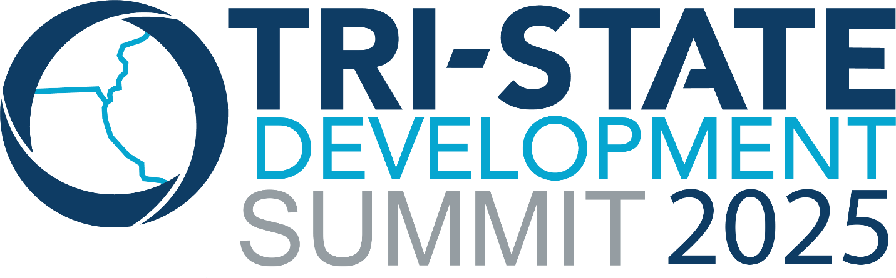
Wednesday, September 24th
_________________________________________________________________________________________________________
1:00 PM - 3:00 PM – Mark Twain Museum Auditorium
Workshop: Economic Development Strategies That Transform Communities
Led by Economic Development expert Allie Bennett, this workshop will highlight proven strategies that drive economic growth, attract investment, and support local businesses.

3:00 PM – Departs from Mark Twain Museum
Main Street Stroll with a Trolley Ride to Sodalis Nature Preserve
Spend the afternoon exploring two of Hannibal’s most unique attractions! With your special Tri-State Development Summit “Shop Downtown Hannibal” ticket you’ll receive a complimentary item from one of several participating downtown merchants to enjoy while you browse local shops and soak in the charm of Main Steet.
Then hop aboard the trolley for a ride to the Sodalis Nature Preserve – a nearly 200-acre park that is home to more than 200,000 federally endangered Indiana bats. This former limestone mine and surrounding caves offer a rare look at one of the region’s most fascinating natural habitats. While at the park, participants will have a chance to take a side-by-side ride up to the bat cave entrances for a closer view.

5:00 PM
Mingle after hours at the Mark Twain Museum
Kick back and connect with fellow Summit attendees in one of the region’s most iconic settings – the Mark Twain Museum!

