Regional Messaging Toolkit
About the Toolkit
The Regional Messaging Framework establishes the regional message and this Toolkit provides ready-to-use language and graphics communities can customize.
Core Message
Where Time, Money, and Opportunity Come Together, People Find Their Place.
Find Your Place.
Across the Tri-State Development region, communities offer a place where time, money, and opportunity come together.
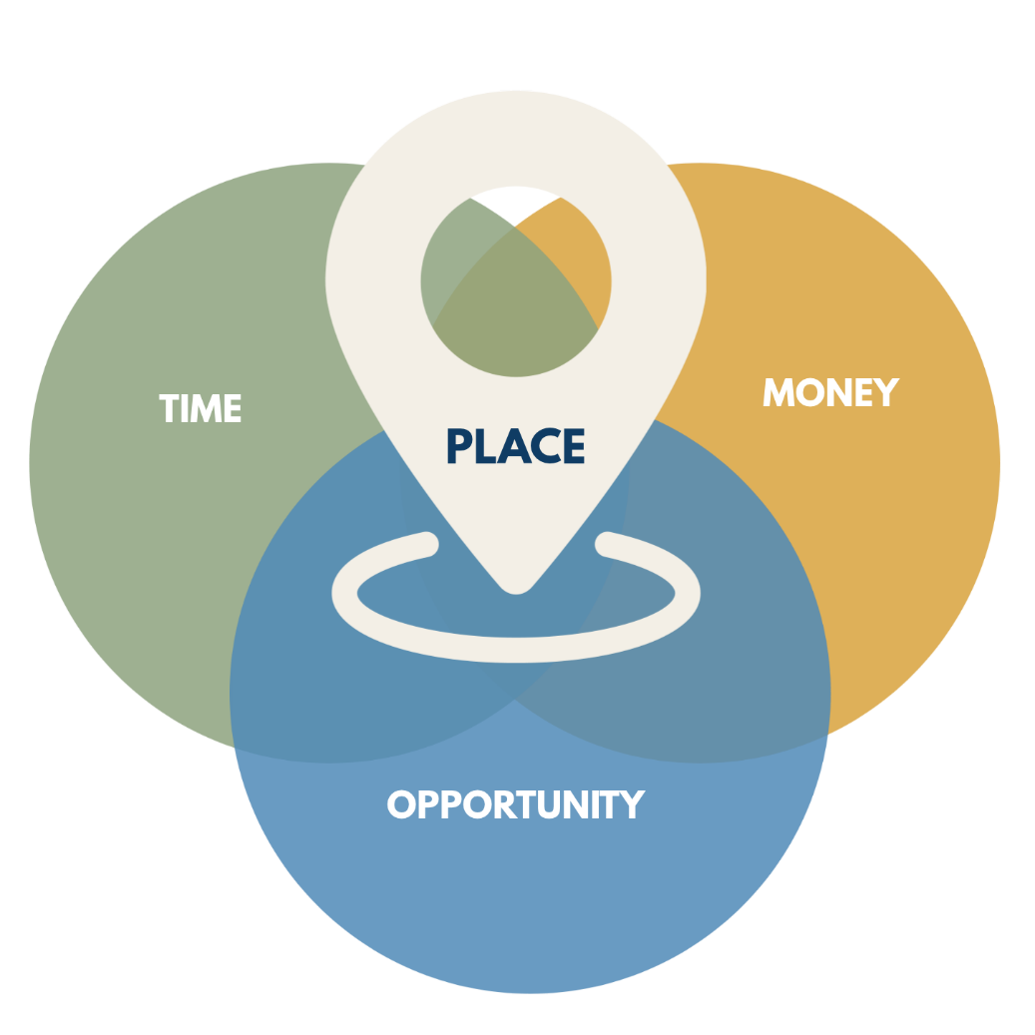
Community Use Example
[Community] offers the balance people are searching for – time to enjoy life and community, affordability, and opportunities to grow and contribute.

TIME
Regional Message
The Tri-State region offers something many people are looking for: more time.
With shorter commutes and less congestion than nearby metro areas, residents often spend less time getting where they need to go and more time doing what matters most.
Community Use Examples
In [Community], residents can leave work, attend a school event, stop downtown, and still have time left in the evening. That kind of accessibility helps strengthen families, organizations, and communities.
[Community] offers residents more time for family, recreation, and community involvement through shorter commutes and convenient access to daily activities.
Social Media Example
Shorter commutes and less congestion can mean more time for family, recreation, community involvement, and personal well-being.
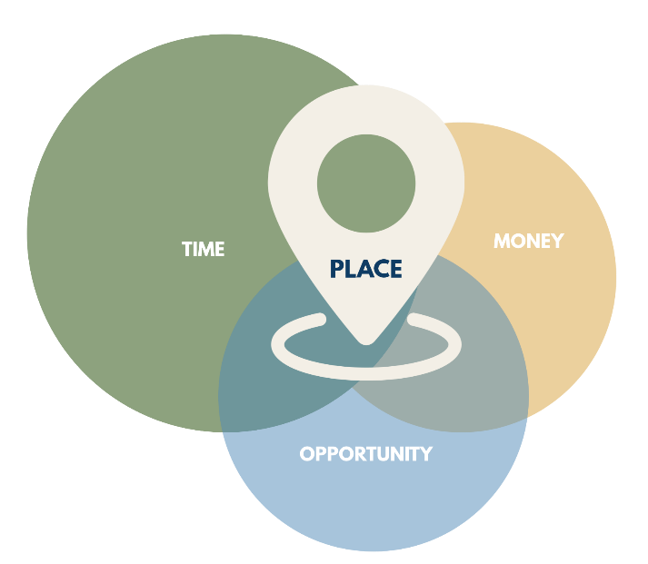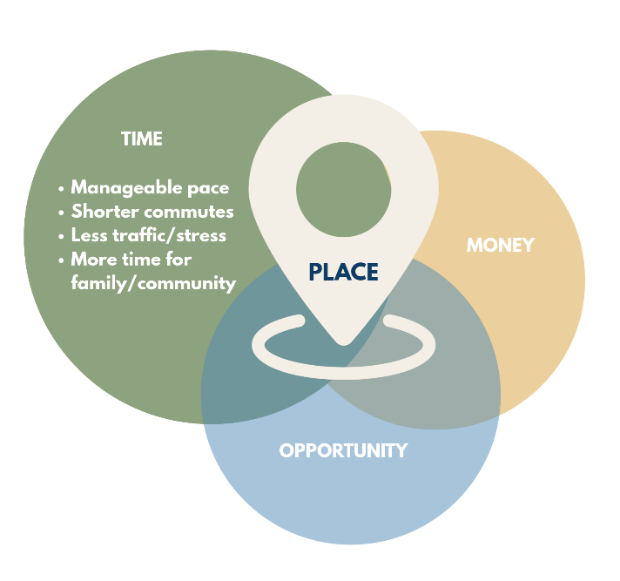

MONEY
Regional Message
Compared to many larger cities, housing costs and everyday expenses can be more manageable. For residents, that can mean greater financial flexibility.
Community Use Examples
Housing costs in [Community name] remain below many larger markets, allowing residents to often get more home for their money while maintaining access to employment, healthcare, education, and recreation.
Housing costs in [community] remain below many larger markets. Residents often find they can get more home for their money while maintaining access to the amenities and opportunities they value.
Social Media Example
Compared to many larger cities, [community’s] housing costs and everyday expenses can be more manageable, helping residents make the most of their resources.
[Add local/regional housing data.]
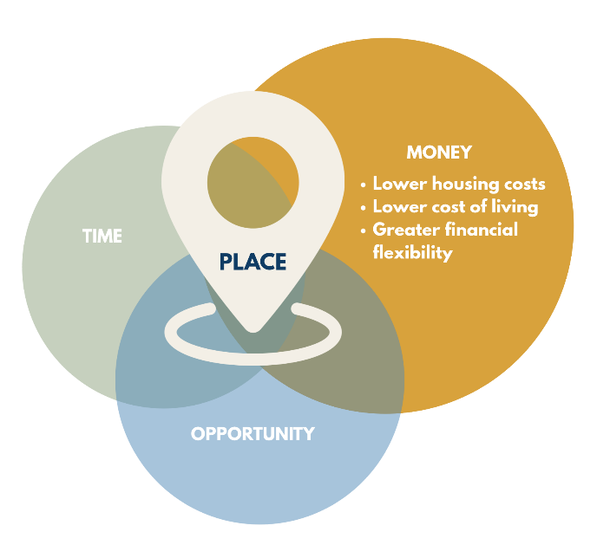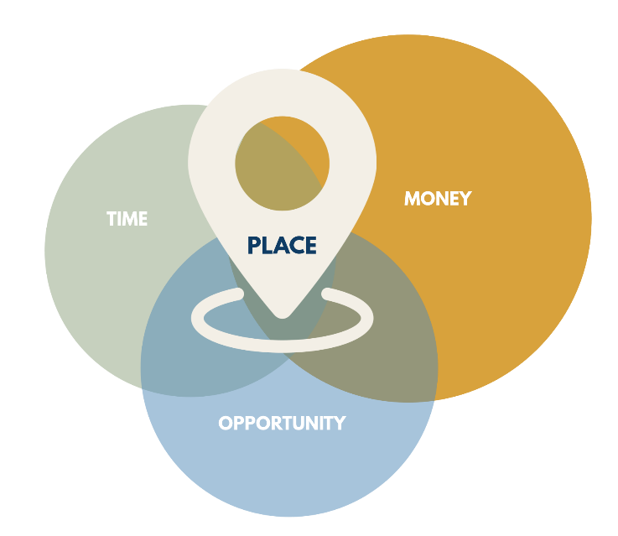

OPPORTUNITY
Regional Message
Opportunity in the Tri-State region extends beyond employment. A diverse economy and strong entrepreneurial culture create pathways for careers, business ownership, leadership, and community involvement.
Community Use Examples
[Community] offers opportunities to build a career, start a business, and become involved in shaping the future of the community through local organizations, leadership roles, and civic engagement.
[Community] offers opportunities to build a career, grow a business, and contribute to the future of the community through leadership and civic involvement.
Social Media Example
From careers and entrepreneurship to leadership and community involvement, the Tri-State region offers opportunities to grow, contribute, and make an impact.
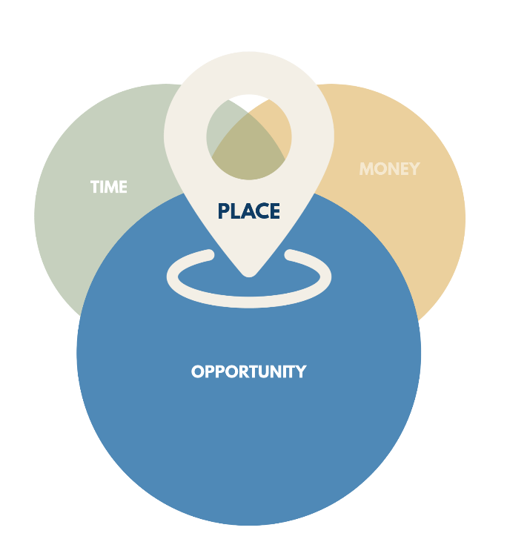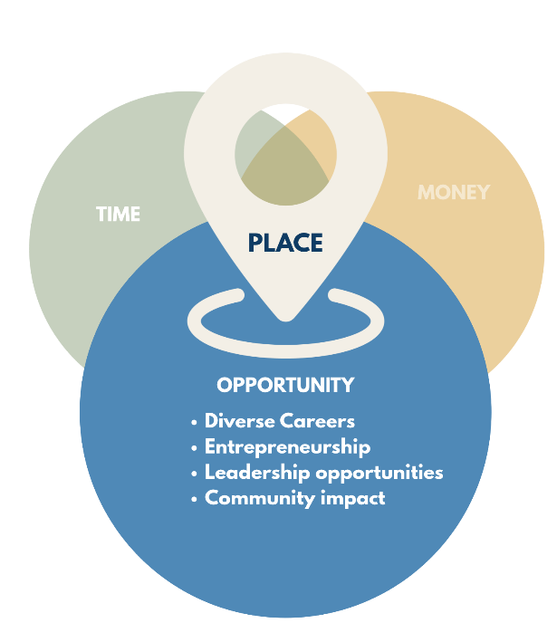
Visual Identity/Color Use
Time — Green — #8DA27E
Affordability — Gold — #D8A23C
Opportunity — Blue — #4F89B7
The full graphic uses color at 85% opacity. When one message area is highlighted, that color appears at 100% opacity while the remaining circles appear at 50%.
Dos & Don’ts
DO
- Use the provided graphics as designed.
- Customize the sample language with your community’s name and local examples.
- Add local data, photos, stories, or examples that support the Time, Money, and Opportunity message.
- Use one message area individually – Time, Money, or Opportunity – when it best fits your content.
- Use the graphics in community websites, social media, presentations, relocation materials, and other marketing efforts.
- Maintain the connection between Time, Money, Opportunity, and Place when using the full graphic.
DON’T
- Stretch, distort, rotate, or alter the proportions of the graphics.
- Change the colors of the circles or other graphic elements.
- Add, remove, or rearrange circles or graphic elements.
- Add a fourth message area or change Time, Money, Opportunity, or Place to different terms.
- Place text, logos, or other elements over the graphics in a way that interferes with readability.
- Alter the graphics in a way that changes the meaning or overall regional message.
Potential Uses
- Community websites
- Relocation guides
- Talent attraction materials
- Chamber and economic development marketing
- Social media campaigns
- Presentations

Downloadable Graphics
Download the approved graphics below for use in your community’s marketing and communications. (PNG files are for daily social media and emails. SVG files are vector files meant for web developers or large-scale printing.)
Full Regional Graphic
PNG/SVG
Time Graphic
PNG/SVG
Time Graphic w Bullets
PNG/SVG
Money Graphic
PNG/SVG
Money Graphic w Bullets
PNG/SVG
Opportunity Graphic
PNG/SVG
Opportunity Graphic w Bullets
PNG/SVG

